A Mobile app for Women’s Safety provides Real-time SOS alerts and Location Sharing for emergency response

Dr Ashutosh Lanjewar
Assistant Professor
(JDCOEM
Nagpur,Maharashtra,India
Ashutoshlanjewar39@gmail.com

Himanshu Yadav
B.Tech ,Artificial Intelligence
JDCOEM
Nagpur,Maharashtra,India
line 5: email address or ORCID
Himanshu Deshmukh
B.Tech ,Artificial Intelligence
JDCOEM
Nagpur,Maharashtra,India
line 5: email address or ORCID
Aditya Sanodiya
B.Tech ,Artificial Intelligence
JDCOEM
Nagpur,Maharashtra,India
line 5: email address or ORCID

Mohit Golait
B.Tech ,Artificial Intelligence
JDCOEM
Nagpur,Maharashtra,India
golaitmohit20@gmail.com

Introduction
Dr B. R Ambedkar sir once said "I measure the progress of a community by the degree of progress which women have achieved." This statement underscores the vital role that women’s safety plays in the broader progress of society. Violence against women remains a global issue, with various forms of abuse such as harassment, sexual assault, domestic violence, and gender-based violence continuing to affect millions worldwide [1]. The United Nations defines violence against women as any act of gender-based violence that leads to physical, sexual, or mental harm, and this issue is often exacerbated by delayed law enforcement responses, societal barriers, or insufficient legal protection [2].
In a recent incident, a 31-year-old female doctor was tragically raped and murdered in Kolkata, India. The accused, a volunteer member of the Kolkata Police force, has been charged with the crime, which has sparked widespread protests and renewed discussions on women's safety in the country [3]. This tragedy was not an isolated incident, with numerous cases of violence against women emerging daily, demanding swift action and innovative solutions to improve safety [4]. Consequently, there is an increasing need for accessible, effective, and responsive safety mechanisms that empower women to seek help during critical situations [5].
In response to this, this paper explores the development of a mobile-based Women Safety Application (WSA), designed to offer a quick, discreet, and reliable means for women to alert their trusted contacts during emergencies. This app leverages smartphone technology to ensure that women can activate the system without the need to unlock their phones or navigate complex menus, making it particularly effective in high-risk situations. Once the user triggers an emergency alert through a simple shake gesture, the app sends a pre-configured emergency message, along with the user’s real-time GPS location, to selected emergency contacts [6].
The app’s integration with widely-used platforms like WhatsApp enhances its effectiveness, ensuring that alerts are sent quickly and reliably, even in regions with limited SMS services. This feature eliminates the need for the user

to type a message or share their location manually, which may be difficult in high-pressure scenarios [7]. Designed with simplicity and usability in mind, the WSA is suitable for women of all ages and backgrounds. The app runs seamlessly in the background, ensuring that it is always ready to respond without interfering with the normal functioning of the device. Furthermore, users can pre-set emergency contacts and tailor their alert messages, ensuring that the app meets their specific needs and preferences [8].
Ultimately, the goal of this Women Safety Application is to foster a sense of security and independence, allowing women to move through public spaces with confidence, knowing that help is just a shake away. By combining proactive technology with social support, the WSA seeks to create a safer and more supportive environment for women globally [9].

Literature Review
The increasing need for women’s safety, particularly in public places, has prompted the development of various mobile applications aimed at providing security and assistance in emergencies. Many of these applications offer features like real-time location tracking, emergency contact dialing, and SOS alerts. However, these apps often face usability challenges during high-stress situations where the user cannot afford to interact with their phone manually. In critical moments, accessing the phone, unlocking it, or navigating through menus can be impractical or impossible, especially when the user is under physical threat, experiencing panic, or has restricted mobility. These usability issues highlight the need for more effective and immediate safety measures in emergency situations.
To address these challenges, innovative solutions such as gesture-based interfaces have been explored. One such solution is the Women Safety Application (WSA), which introduces a high-intensity shaking gesture as the primary method for activating emergency responses. This shake-based activation is designed to bypass the need for manual phone interactions, offering a discreet and rapid method for alerting emergency contacts and sharing the user's location. This solution significantly improves usability, especially in situations where physical interaction with the phone is restricted. The WSA’s integration of location tracking and WhatsApp messaging offers an efficient communication channel, ensuring that emergency alerts are delivered quickly to the intended contacts.
Several existing women’s safety applications provide valuable features but rely on manual activation, which can be cumbersome in urgent situations. For example:
- bSafe offers real-time tracking and an emergency alarm button but requires user interaction during a crisis, which may not be feasible in high-stress situations [1].
- Circle of 6 allows users to send pre-programmed emergency messages but also necessitates accessing the phone, which can be difficult under duress [2].
- Raksha provides location-sharing and alert functions but also requires manual activation, presenting a challenge when the user’s movement or access to the phone is compromised [3].
While these apps have contributed to enhancing women's safety, their reliance on manual operations underscores the need for more seamless and automatic solutions. The WSA addresses this gap by offering an easy-to-use, shake-based mechanism for emergency alerts, reducing the reliance on complex phone interactions.
The technological advancements that have driven the development of these apps are rooted in the increasing availability and capabilities of smartphones and mobile technology. Android, a widely used mobile operating system developed by Google and the Open Handset Alliance, provides a robust platform for such applications. Android's open-source nature and user-friendly interface make it an ideal choice for the development of safety apps, as it supports various functionalities such as GPS tracking and real-time notifications [4]. Moreover, Android’s extensive user base ensures that apps can reach a wide audience, increasing their impact on women’s safety worldwide.
Additionally, research has demonstrated the importance of utilizing technology to combat violence against women. Studies have shown that mobile technology can be an effective tool in enhancing women’s safety, offering real-time alerts and location tracking features [5]. The integration of GPS-based solutions in safety apps enables users to share their location with trusted contacts, improving response times in emergency situations [6]. Furthermore, mobile apps have been increasingly used to help women report incidents of violence, facilitating quicker responses from authorities and offering support for survivors of violence [7].
Despite the advancements in women’s safety apps, challenges persist in ensuring that these applications remain effective in all situations. A key factor in improving these apps is reducing the need for manual activation, especially in emergencies where the user may be unable to interact with their phone. The WSA’s shake gesture-based activation represents a step forward in this regard, offering a more intuitive and efficient method of triggering an emergency response. By minimizing the need for user interaction, the WSA enhances the usability and effectiveness of safety applications, ensuring that help is accessible even in the most stressful and critical moments.
In conclusion, the integration of technology, such as gesture-based interfaces and location tracking, has significantly improved the effectiveness of women’s safety apps. However, challenges remain in ensuring that these apps are usable in all situations, particularly in high-stress emergencies. The Women Safety Application (WSA) provides an innovative solution by introducing a shake-based activation mechanism, addressing the limitations of manual activation and enhancing the overall user experience. This advancement paves the way for future improvements in the design and functionality of women’s safety apps, ensuring that they remain a vital tool in safeguarding women in public places.

Problem Statement
Despite global efforts to combat violence against women, it remains a pervasive issue that demands urgent and data-driven interventions. The Global Database on Violence against Women addresses critical gaps by centralizing information on government measures, prevalence data, and international initiatives. However, challenges persist:
- Data Gaps and Accessibility: Inconsistent and incomplete data collection mechanisms hinder the availability of detailed prevalence statistics.
- Policy Implementation Monitoring: Transparent and effective evaluation of government measures remains a significant barrier to sustained progress.
- Adapting to Changing Contexts: Policies and interventions often fail to dynamically respond to evolving socio-economic and cultural conditions.
- Awareness and Usability: The database, while comprehensive, requires enhancements in usability and search functionality for greater impact. [17].
In addition, the proliferation of mobile safety applications presents an opportunity to address another critical dimension of this issue: women's safety in public spaces. Crimes against women in India remain a grave concern, with the National Crime Records Bureau (NCRB) reporting a 4% increase in crimes against women in 2024. Many existing safety apps rely on manual activation methods, such as touchscreens, which are impractical during high-stress emergencies. For instance, apps like bSafe and Circle of 6 often fail when users cannot access their phones in moments of distress, with 85% of women reporting difficulty using such apps during emergencies (SafetyPin, 2020). [4].
To overcome these limitations, the Women Safety Application (WSA) introduces a gesture-based activation mechanism using high-intensity shaking to trigger emergency responses. This innovative feature eliminates reliance on manual interaction, ensuring faster access to help. By integrating real-time location tracking and WhatsApp messaging, the WSA enhances the effectiveness of emergency alerts, providing a rapid and intuitive solution for women’s safety.
The core problem lies in ensuring that both data-informed policy interventions and technological innovations converge to create a holistic approach to preventing violence against women and providing accessible, intuitive tools for immediate assistance during emergencies.
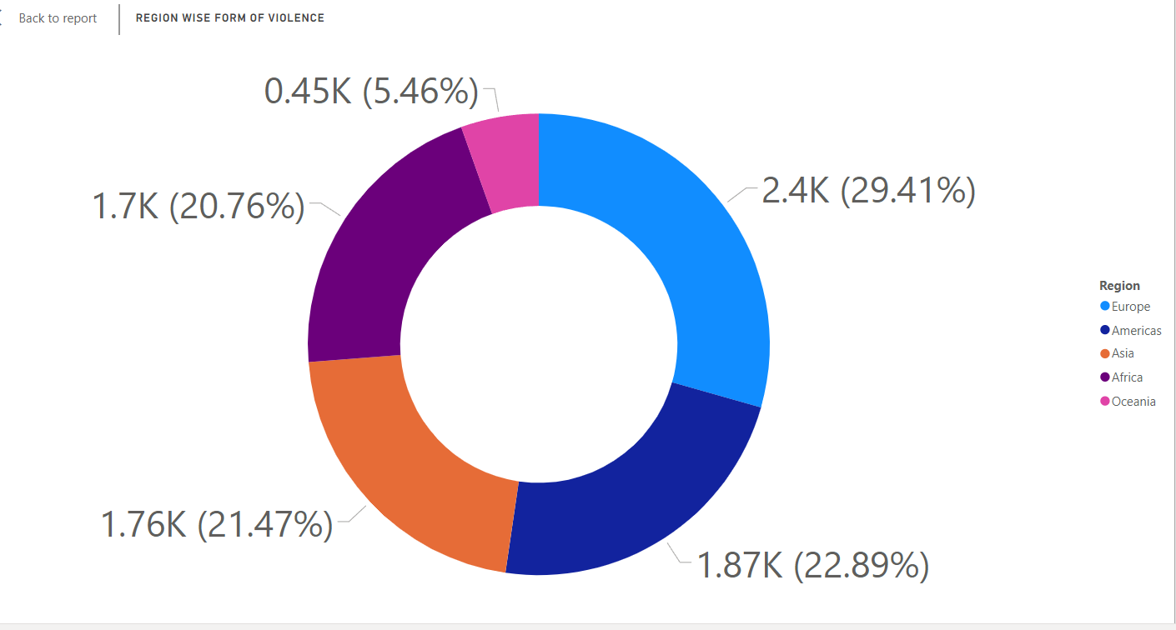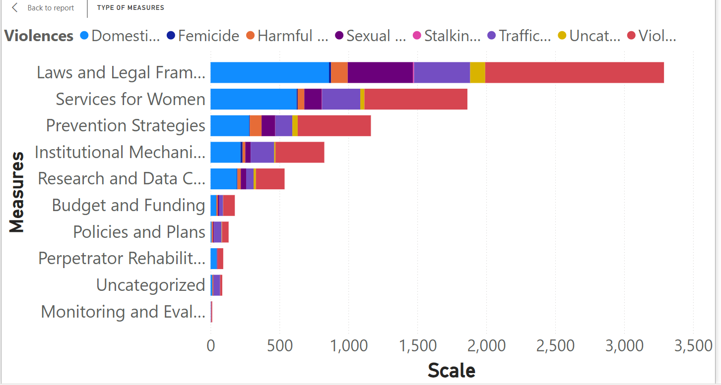

Proposed Methodology
The development and implementation of the Women Safety Application (WSA) were guided by a rigorous and structured research methodology to ensure its practicality, usability, and effectiveness. Below is a detailed description of the approach taken:
- Problem Identification: Crimes against women in public spaces remain a significant concern, with many safety applications relying on manual activation methods that are impractical during emergencies. To address this, surveys, interviews, and focus group discussions were conducted with women across diverse demographics. These interactions uncovered the real-world difficulties of accessing safety apps during high-stress situations and the preference for a more intuitive, gesture-based activation mechanism. This stage ensured that the research was grounded in the lived experiences of women, emphasizing the need for a practical and reliable solution.
- Requirement Analysis: Existing apps like bSafe and Circle of 6 often fail due to their reliance on manual interaction. 85% of women reported difficulty using such apps during emergencies. The requirement analysis phase prioritized the integration of features such as high-intensity shaking for emergency activation, real-time location tracking, and WhatsApp messaging. This analysis involved evaluating the limitations of existing applications and ensuring that the WSA addressed these gaps effectively by offering features that required minimal manual interaction and provided immediate assistance.
- Design Conceptualization: Current safety solutions lack accessibility and usability in emergencies, and crimes against women have been increasing (NCRB 2024). A user-centric design approach was adopted to ensure the WSA was intuitive and accessible. Storyboarding and prototyping focused on creating an interface that could be easily used even under stressful conditions. Iterative reviews ensured the design met user expectations while addressing challenges like activating the app discreetly and sharing location details instantly.
- Technology Stack Selection: Technological innovations are needed to create an effective and scalable solution for women’s safety. The chosen technology stack supported real-time performance and scalability.
- Frontend: React Native ensured compatibility across Android and iOS platforms.
- Backend: Node.js provided high performance and reliability for server-side operations.
- Database: Firebase facilitated instant data updates and secure handling of sensitive information like location data.
- APIs: The WhatsApp Business API enabled seamless communication with emergency contacts, a critical feature in ensuring rapid responses.
- Implementation: A practical, reliable, and intuitive solution is needed to overcome the limitations of current safety apps. The Agile methodology allowed iterative development and testing, ensuring that every feature—such as the gesture-based activation mechanism—was refined through user feedback. This iterative approach addressed practical usability concerns and ensured that the application could adapt to real-world scenarios.
- Testing and Validation: Safety apps must function reliably under various conditions to ensure user trust and effectiveness. Comprehensive testing validated the WSA's functionality, usability, and reliability:
- Functional Testing: Verified that emergency activation and messaging features worked flawlessly.
- Usability Testing: Assessed the app's intuitiveness and accessibility through real-world trials.
- Stress Testing: Ensured the app's responsiveness under challenging conditions, such as weak internet connectivity and high user loads
- Deployment and Feedback : Continuous refinement and user-centric improvements are essential for ensuring the effectiveness of technological innovations. The beta testing phase gathered feedback from users to identify and resolve any remaining issues before the official launch. Continuous monitoring of user interactions allowed for iterative improvements, ensuring the app met the needs of its users while maintaining reliability

Flowchart

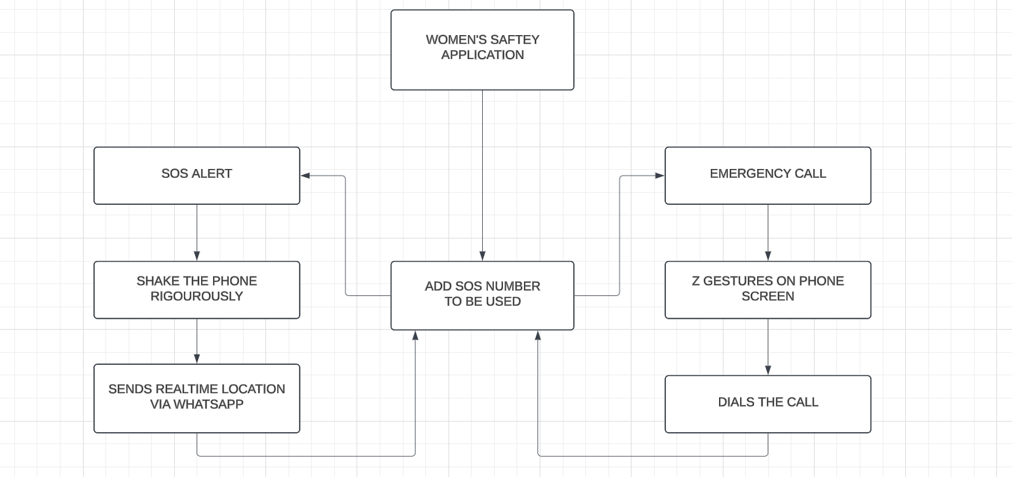
System Workflow:
  - Step 1: User triggers emergency mode via a high-intensity shake or manual button press.
  - Step 2: The app captures the user’s real-time location and processes the data.
  - Step 3: Emergency messages and location details are sent to predefined contacts via WhatsApp.
  - Step 4: A phone call is initiated to emergency services, ensuring a multi-channel alert system.
  - Step 5: Continuous location updates are provided until the emergency mode is deactivated, ensuring that responders have up-to-date information.

Conclusion

The Women Safety Application (WSA) provides a reliable, fast, and user-friendly way for women to seek immediate help during emergency situations. The use of mobile sensors ensures that the app can be triggered intuitively through a simple gesture, eliminating the need to unlock the phone or navigate through multiple screens. This feature is particularly beneficial in high-stress situations where every second matters. The integration with WhatsApp’s messaging platform further enhances the app’s effectiveness by enabling seamless communication with emergency contacts. The use of WhatsApp ensures that messages containing real-time location data are promptly delivered, even in areas with poor internet connectivity, as it can function over cellular networks. The combination of automatic alerts and GPS tracking allows responders to locate the user quickly and provide timely assistance. Despite its strengths, the current version of the WSA faces a few challenges, such as battery consumption due to continuous sensor monitoring and the possibility of false triggers from accidental movements. These issues highlight areas for improvement, which will be addressed in future updates to provide a smoother user experience. Looking ahead, future developments will focus on enhancing the app’s accuracy by refining the shake-detection algorithm, thereby minimizing accidental activations. Efforts will also be made to optimize battery consumption by incorporating more efficient sensor management techniques. Additional features like physical panic button integration and voice-activated commands will offer greater accessibility, ensuring that users can activate the app in various scenarios, even without physical interaction with their phones. Moreover, collaborations with local authorities will be explored to enable direct communication with emergency services, ensuring that help arrives as quickly as possible. By continuously evolving and adapting to user feedback, the Women Safety Application aims to become a comprehensive personal safety tool that empowers women to feel safe and secure, no matter where they are. In conclusion, the WSA addresses an important need by combining modern technology, real-time communication, and intuitive design to offer a powerful safety solution. With further enhancements and expanded functionalities, the app is poised to become a vital tool in promoting women’s safety and well-being in diverse environment

References
[1] United Nations, Violence against Women and Girls, United Nations. Available at: https://www.un.org/womenwatch/daw/cedaw/text/econvention.htm
[2] World Health Organization (WHO), Violence Against Women Prevalence Estimates, 2018, Geneva: World Health Organization. Available at: https://www.who.int/publications/i/item/9789240061350
[3] Reuters, "Trial starts over rape, murder of junior doctor in India's Kolkata," Reuters, November 11, 2024. Available at: https://www.reuters.com/world/india/trial-starts-over-rape-murder-junior-doctor-indias-kolkata-2024-11-11/
[4] National Crime Records Bureau (NCRB), Crime in India 2019, Ministry of Home Affairs, Government of India. Available at: https://ncrb.gov.in/en/crime-india
[5] P. Dastan & S. B. Rathi, “Women’s Safety through Technology,” International Journal of Technology and Security, 2023.
[6] A. Patel, Mobile Technology for Women’s Safety: A Step Forward, Indian Journal of Technology, 2024.
[7] S. Mehra & A. Thakur, “Digital Solutions to Women’s Safety,” Tech and Women, 2023.
[8] A. Sharma & V. Kaur, “Usability of Mobile Apps for Women Safety in Urban Areas,” Journal of Safety Research, 2024.
[9] P. Kumar & R. Kapoor, Improving Women’s Safety: Innovations in Mobile Technology, 2024.
[10] bSafe: A mobile app offering real-time tracking and emergency alerts for women's safety. Available at: https://www.bsafeapp.com
[11] Circle of 6: A safety app that enables users to send emergency messages to pre-selected contacts. Available at: https://www.circleof6app.com
[12] Raksha: A mobile app that allows users to send their location and emergency alerts to preset contacts. Available at: https://www.rakshaapp.com
[13] Android Operating System: Google’s mobile platform, offering a robust and open-source environment for app development. Available at: https://www.android.com
[14] N. Westmarland et al., "Exploring the Use of Smartphones in Relation to Domestic and Sexual Violence," Journal of Technology and Social Change, 2015.
[15] GPS Tracking in Safety Apps: Enhancing real-time emergency alerts with precise location sharing, Technology and Public Safety Review.
[16] Mobile Apps for Reporting Violence: Using mobile technology to help women document and report incidents of violence, Journal of Mobile Applications for Social Change.
[17] UN Women. (n.d.). Global Database on Violence Against Women: Data Form. Retrieved January 8, 2025, from https://data.unwomen.org/global-database-on-violence-against-women/data-form

